**Brandon Hobbs**

**CS-340**

**September 6, 2022**

**Module 2**

* Prompt 2 – Verify the data was loaded  
  Text

  Description automatically generated
* Prompt 3 – Insert a document  
  
* Prompt 4   
  a) There are 87 distinct sectors.  
  Text

  Description automatically generated  
  Text

  Description automatically generated  
  b) Both dates are strings, but the *AUSTIN 2012* date string does not include the full UTC time elements that DATE() added  
    
  c)13,823 businesses have Violations Issued  
  
* Prompt 5 – update the created record  
  
* Prompt 6   
  A) There are 115 ROSEDALE in the documents and all have 11422 as their zip  
  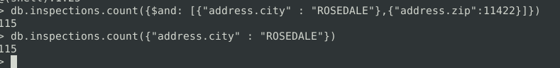  
  Text

  Description automatically generated  
  B) There were 13,822 documents with “result” = “Violation Issued”; after a random deletion there are 13,822 documents  
  Text

  Description automatically generated